PIZZA SALES SQL QUERIES

**Q1. Retrieve the total number of orders placed.**

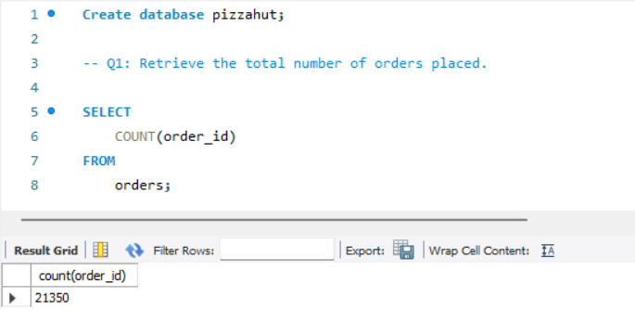

**Q2: Calculate the total revenue generated from pizza sales.**

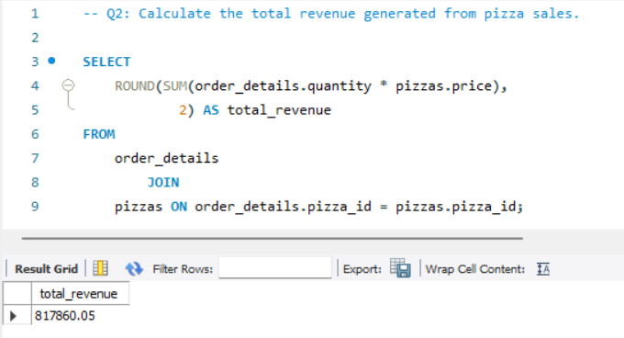

**Q3: Identify the highest-priced pizza**

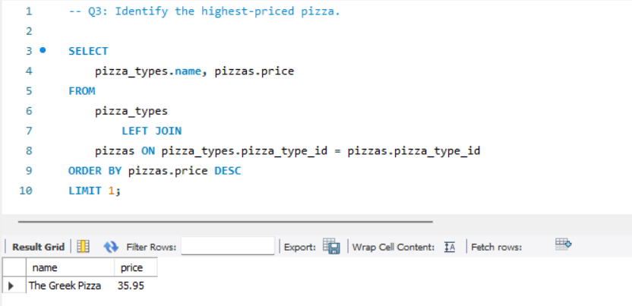

**Q4: Identify the most common pizza size ordered.**

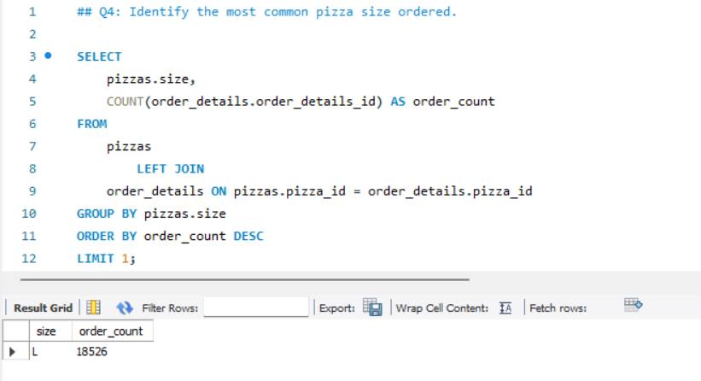

**Q5: List the top 5 most ordered pizza types along with their quantities.**

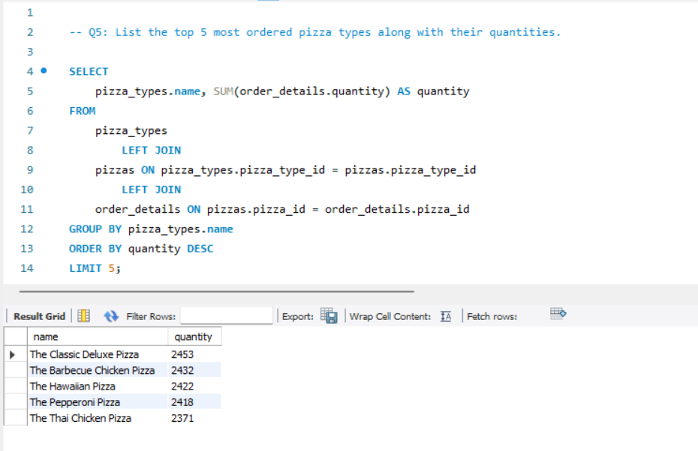

**Q6: Join the necessary tables to find the total quantity of each pizza category ordered.**

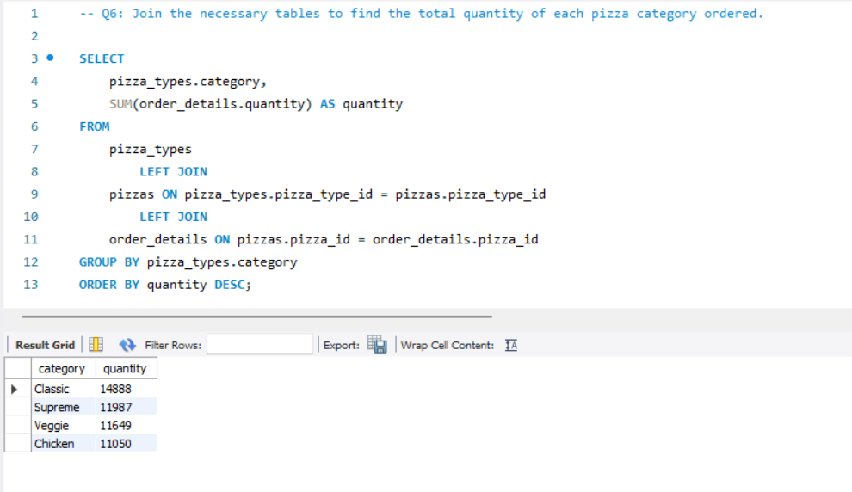

**Q7: Determine the distribution of orders by hour of the day.**

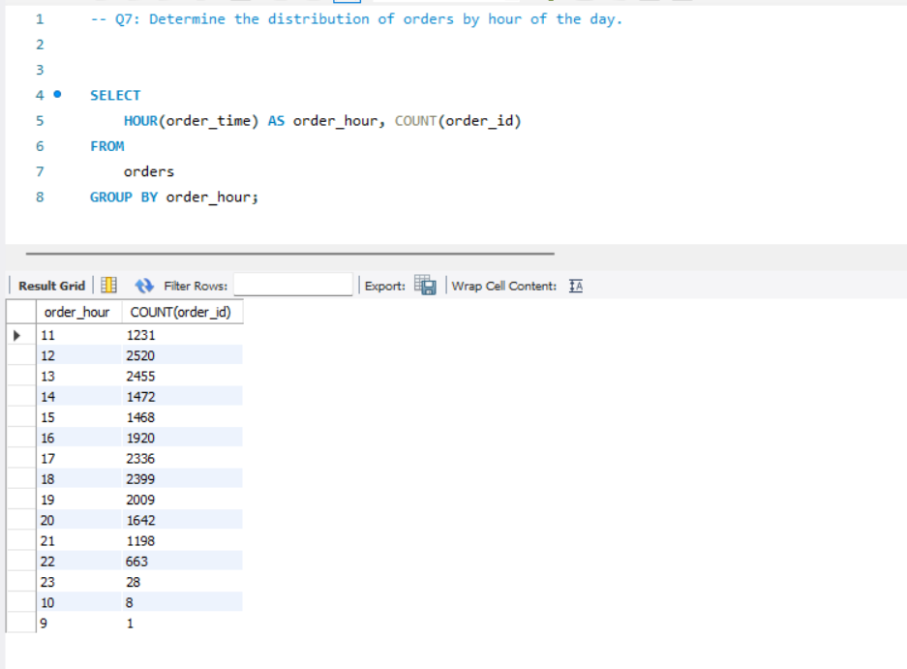

**Q8: Join relevant tables to find the category-wise distribution of pizzas(count pizzas).**

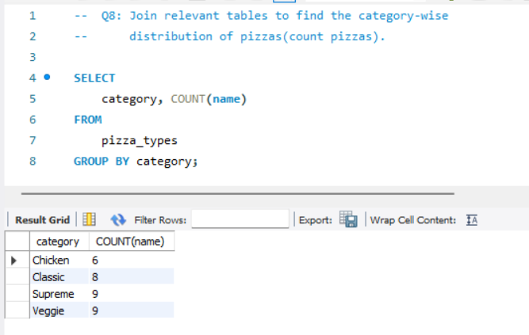

**Q9: Group the orders by date and calculate the average number of pizzas ordered per day.**

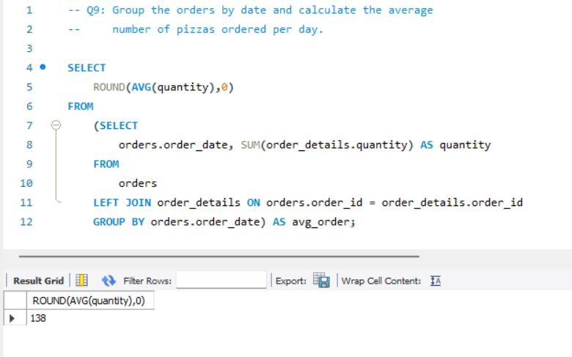

**Q10: Determine the top 3 most ordered pizza types based on revenue.**

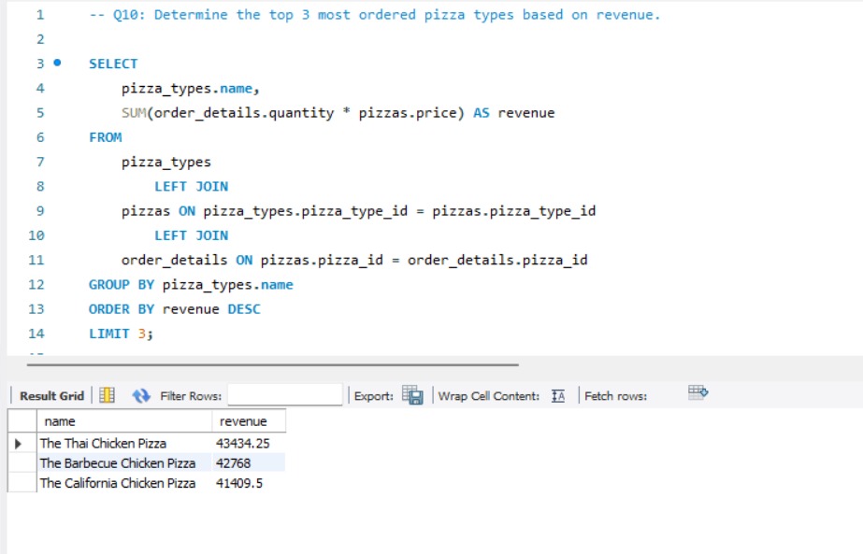

**Q11: Calculate the percentage contribution of each pizza type(category) to total revenue.**

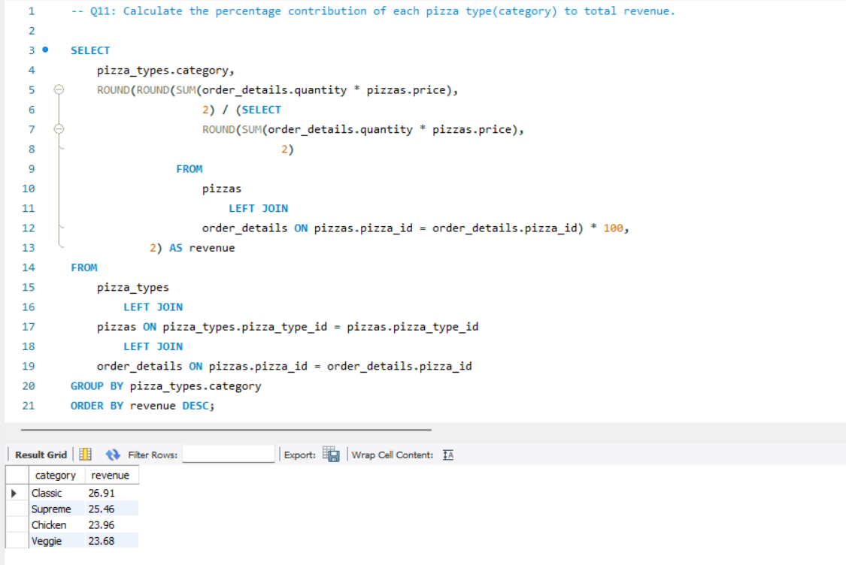

**Q12: Analyse the cumulative revenue generated over time.**

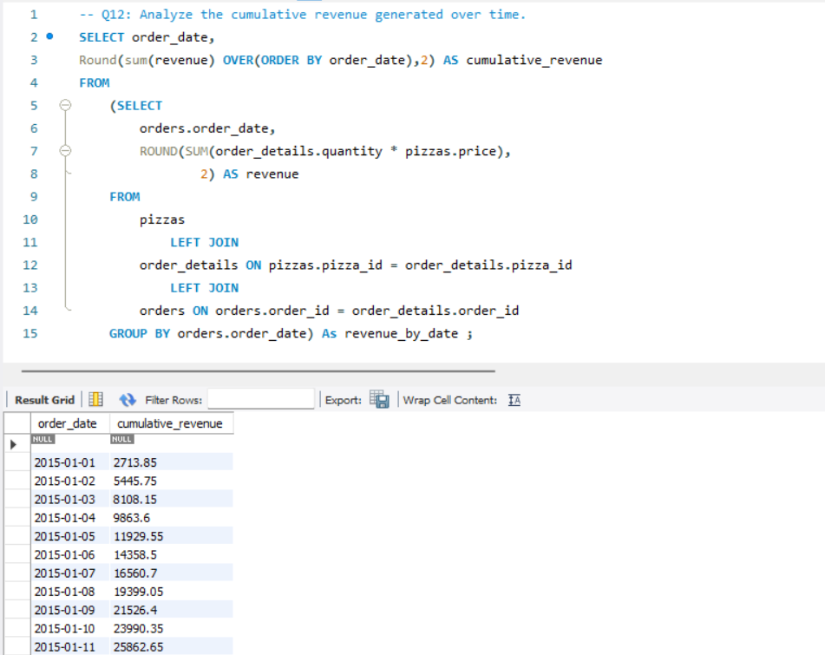

**Q13: Determine the top 3 most ordered pizza types based on revenue for each pizza category.**

